**Introduction and Problem Description:**

Bandung has always been a top destination for holidays or a short weekend gateaway for people living and working around West Java Province and around Jakarta, the capital city of Indonesia, which is only 3 hours away. It is known for the chill air, the great view of nature, and for the various culinary trends. As it is the fourth most populous city in Indonesia with a lot of tourist coming for the foods with the view, many people are interested in opening a restaurant in here. In this project, I would like to recommend the best location to open restaurants with the best view and near to tourist's lodging based on Foursquare location data.

**Data Description:**

I use a combination of csv data and Foursquare location data. I found the csv file from this link: <http://data.bandung.go.id/dataset/0ac32316-8450-4064-b7f2-48049439ff5e/resource/6a568b69-5e41-4ea0-80ca-0487341fe9f3/download/koordinat-dan-ketinggian-kantor-kelurahan-di-kota-bandung-2014.csv>. The csv file contains data of the name of sub-districts, villages, their coordinates, and elevations. The Foursquare location data would provide me with venues' categories, names, and locations to know which kind of venues are the most common in each area thus I could know the restaurants that are the most common, the variability of venues in each location, and the density of venues. From this data I could predict the aims of people coming to each location, the best target market, and the potential competitors.

**Methodology:**

I use Jupyter Notebook to conduct this research. The data column names are written in Indonesian language. Therefore, I first convert the column names into English. As the best view locations are located in the higher ground, I sort the elevation values from highest to lowest.

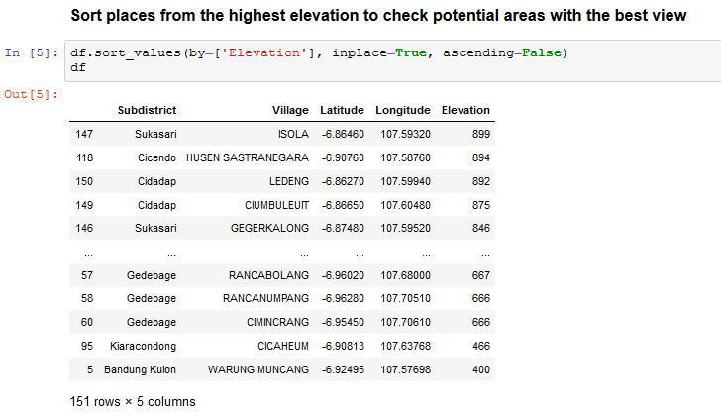The data shows the highest point is 899 meters above sea level which is in Isola Village, Sukasari Subdistrict and the lowest is 400 meters above sea level in Warung Muncang Village, Bandung Kulon Subdistrict. After that, I decided slice the data frame to narrow the options to areas higher than 790 masl and resulted in 13 villages.

**Result**

Using Foursquare API, I explore the venues around these 13 villages. Firstly, I check the amount of the top venues within 200 meters radius in each neighborhood to know the crowd. The least number venue is 4 venues in Pasanggrahan Village, and the most abundant venue is 36 venues in Gegerkalong Village. After that, I check 5 most common venues in each neighbourhood and cluster the neighborhood into 5 clusters using k-means. Next, I visualize the cluster point on the map and examine each cluster.

In Cluster 1, the first common venues are hotels, followed by various venues namely café, coffee shop, garden, and convenience store. Cluster 2 is dominated by a mix of hotel, café, bookstore, coffee shop, restaurants, convenience store, sport stadium, concert hall, and convention center. Cluster 3 only contains of one neighbourhood with Korean restaurant as the most common venue, followed by various stores. Cluster 4 contains four areas, with the most common venue is Indonesian restaurant, convenience store, and coffee shop, followed with various types of venues. Cluster 5 is dominated by fast food restaurant and followed by various types of venues.

Isola Map

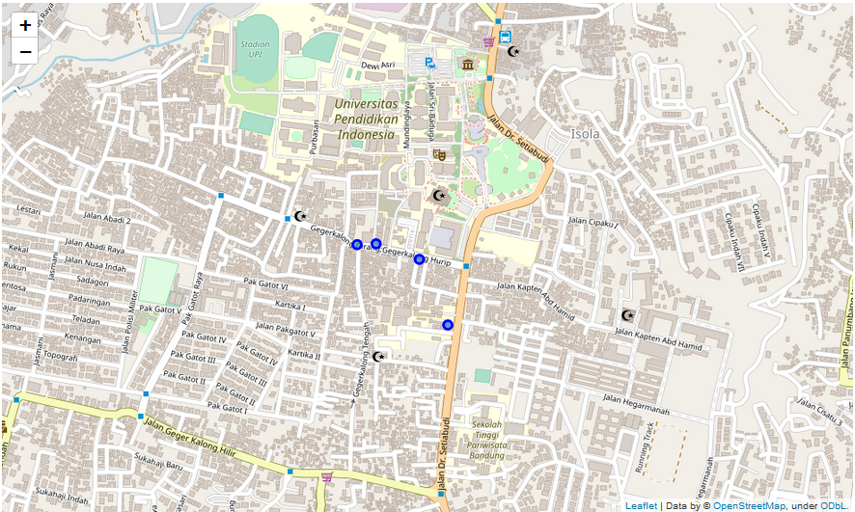

Ledeng Map

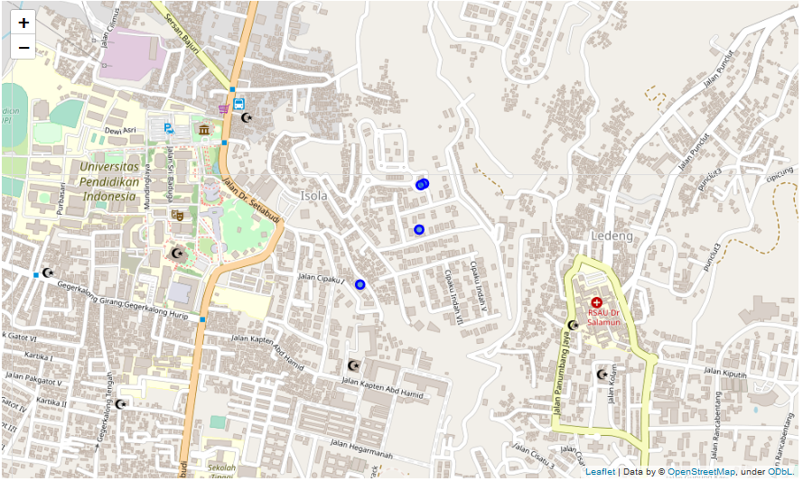

Cigadung Map is not shown because it has no sufficient amount of venues in radius of 200 m.

**Conclusion**

From this data, Cluster 1 is the perfect place for our restaurant. It is dominated by hotel which means a lot of tourist stays there and it is surrounded by many food stops. On the map, the area of Cluster 1 is mostly located in the northern part of Bandung which is known for its beauty. This cluster comprise of five villages namely Isola, Ledeng, and Cigadung. If we look back to the number of venues in each village, we find that Isola has 30 venues, Ledeng has 13 venues, and Cigadung has 5 venues.